Solution: Plotting Triangles and Circles

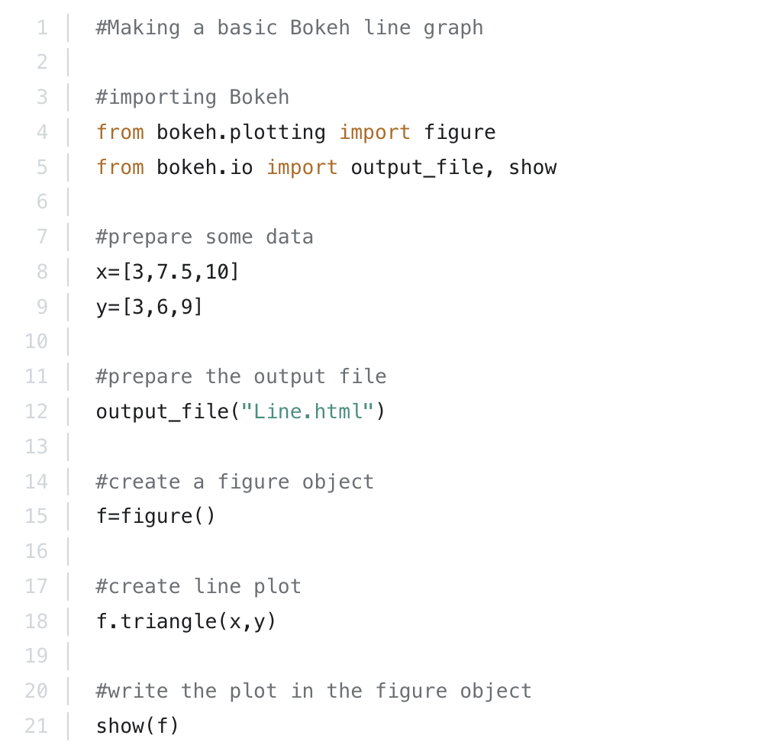
#Snippet producing the triangle-based plot

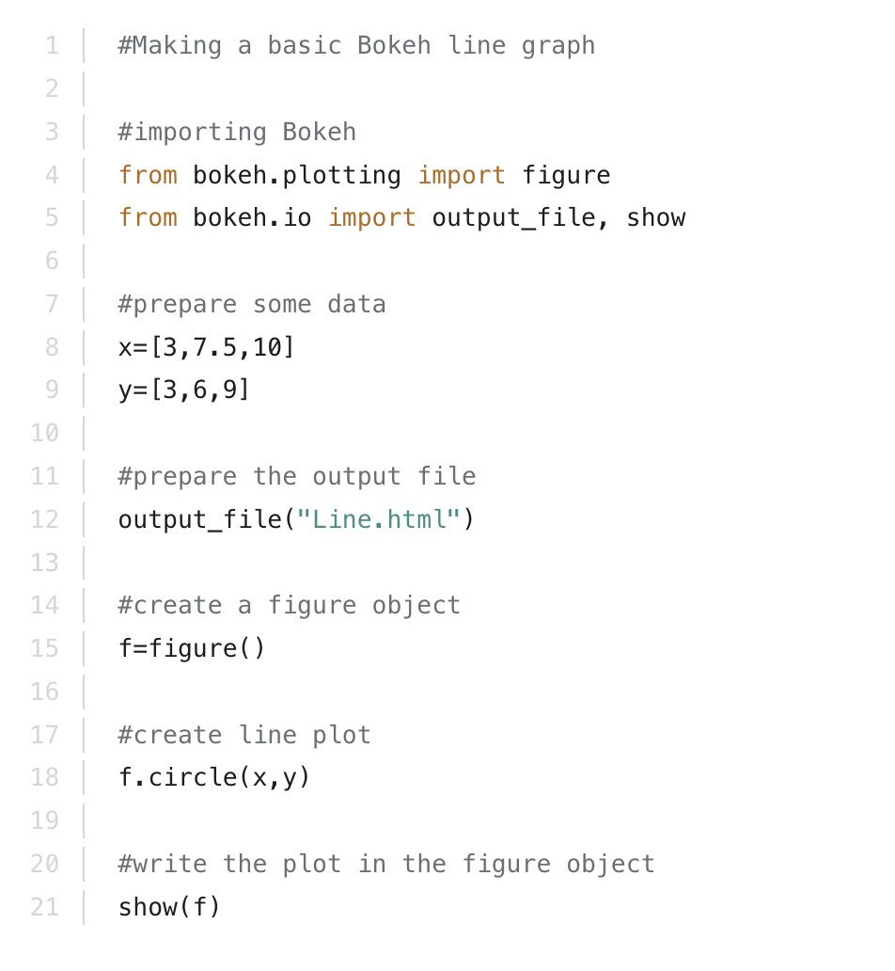
#Snippet producing the circle based plot

